MongoDB Find Operations

1️⃣ Find the First 5 Movies Sorted by Year (Descending Order)
(Retrieve the latest movies based on release year)

Edit
db.movies.find()
.sort({ "year": -1 })
.limit(5)

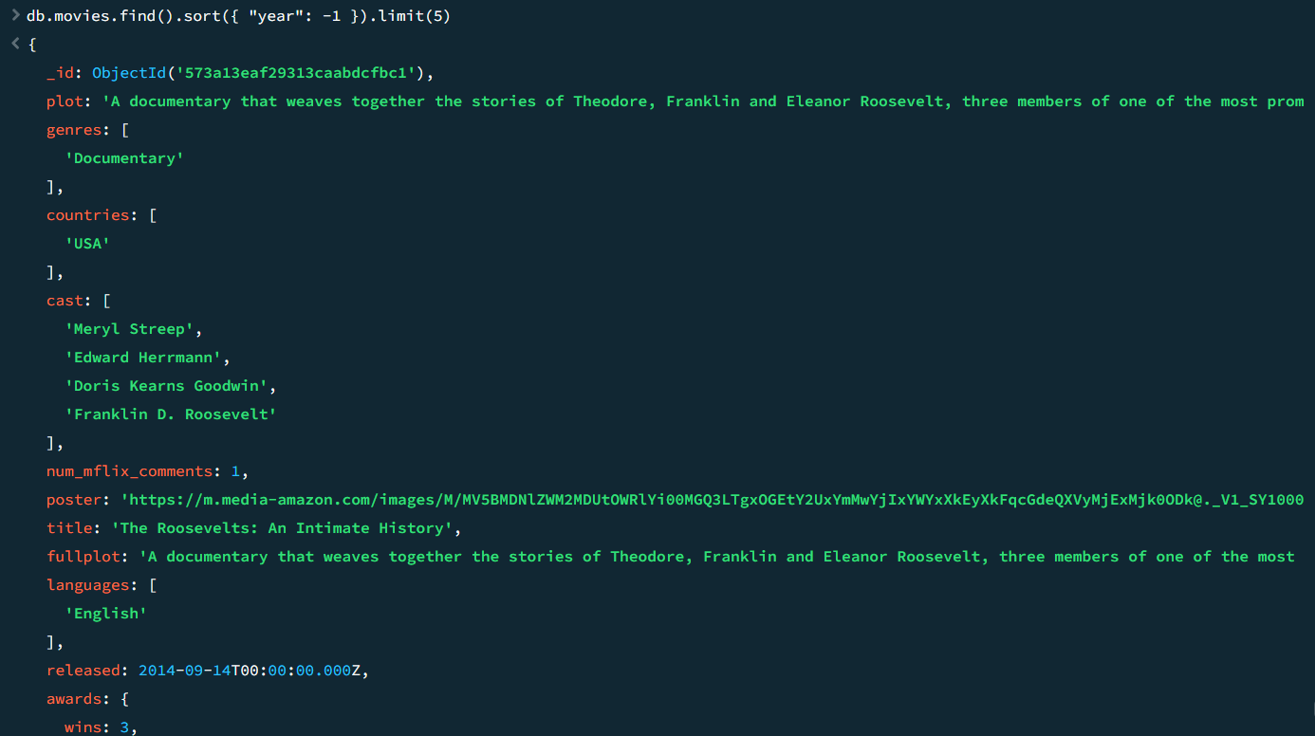

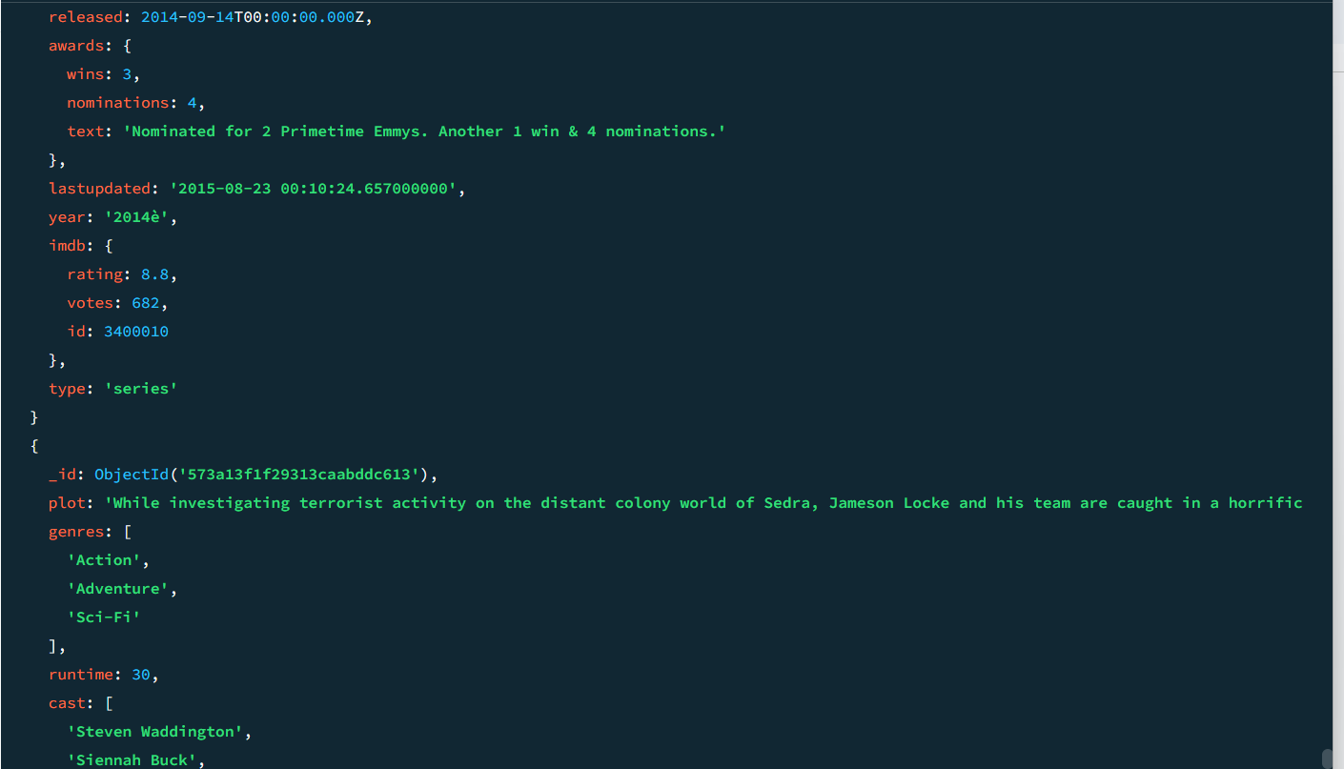

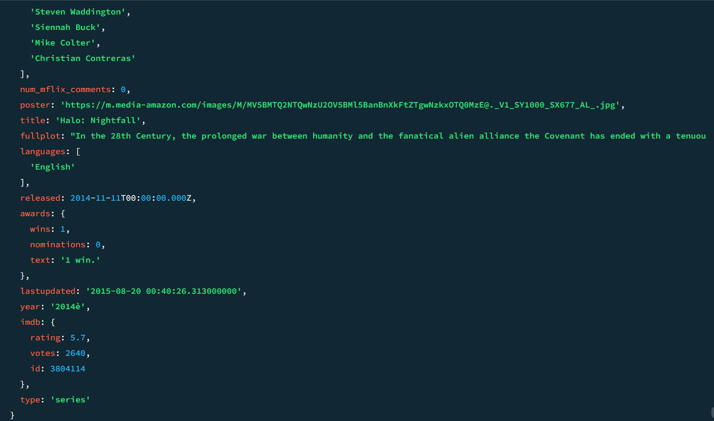

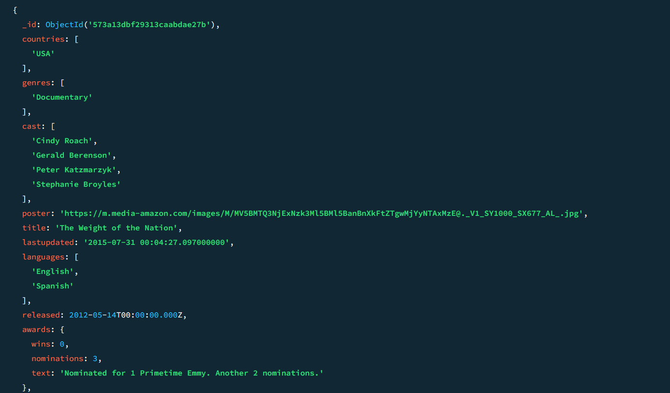

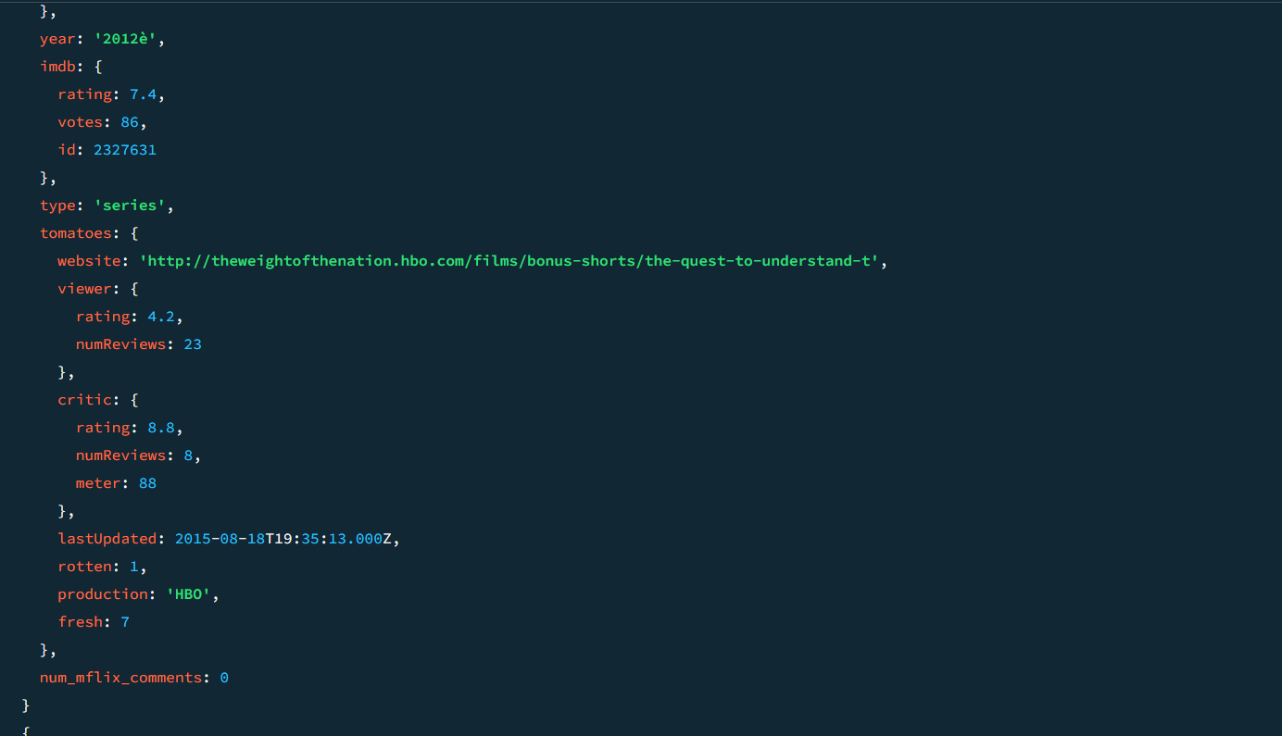

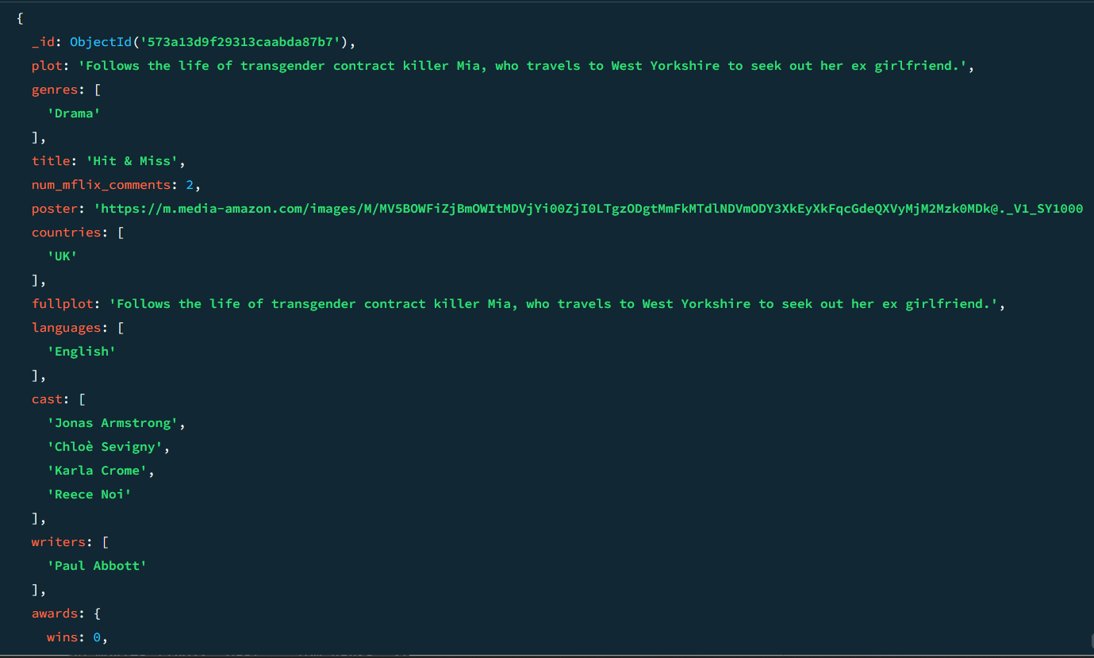

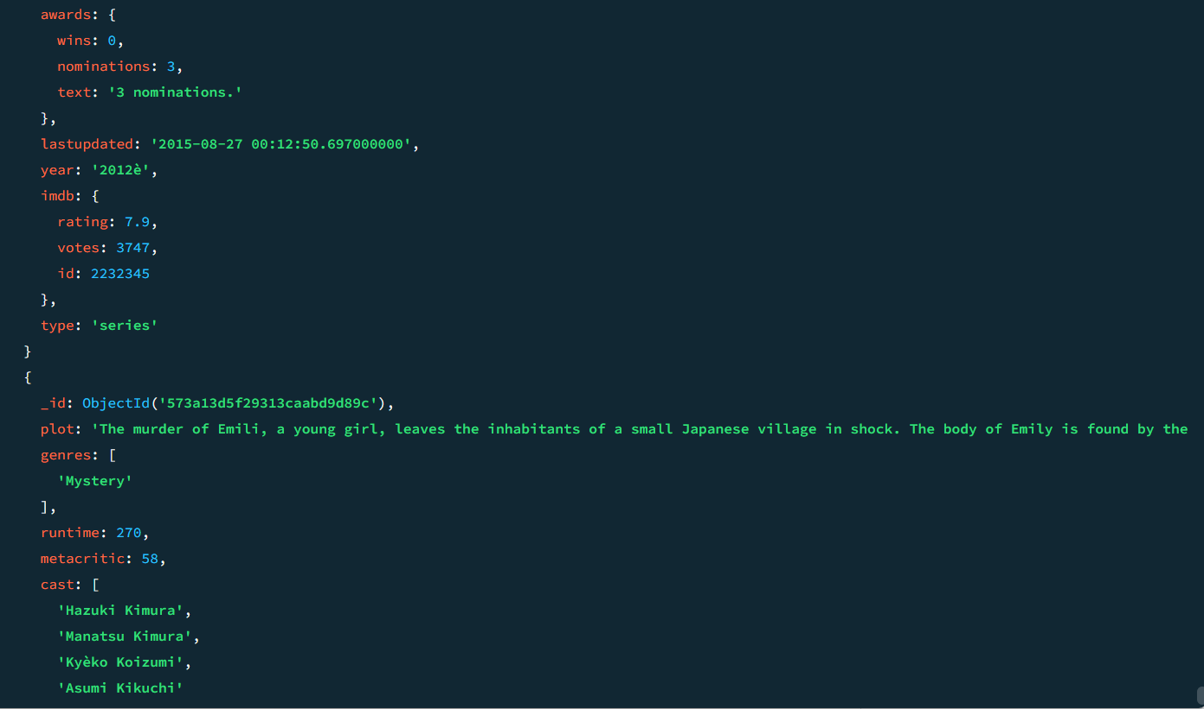

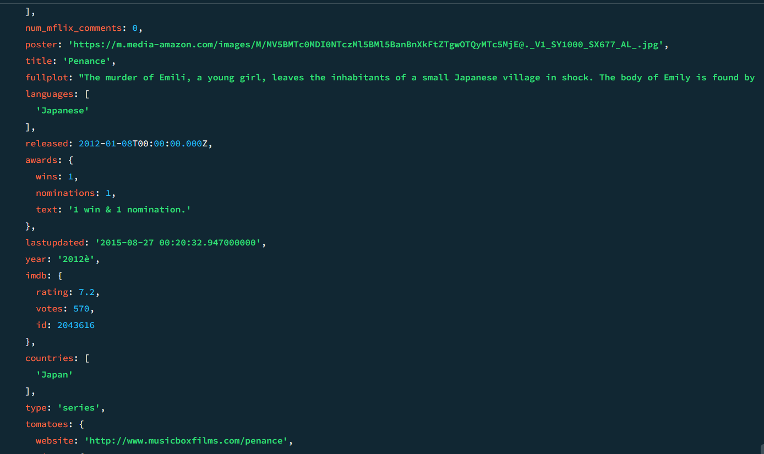

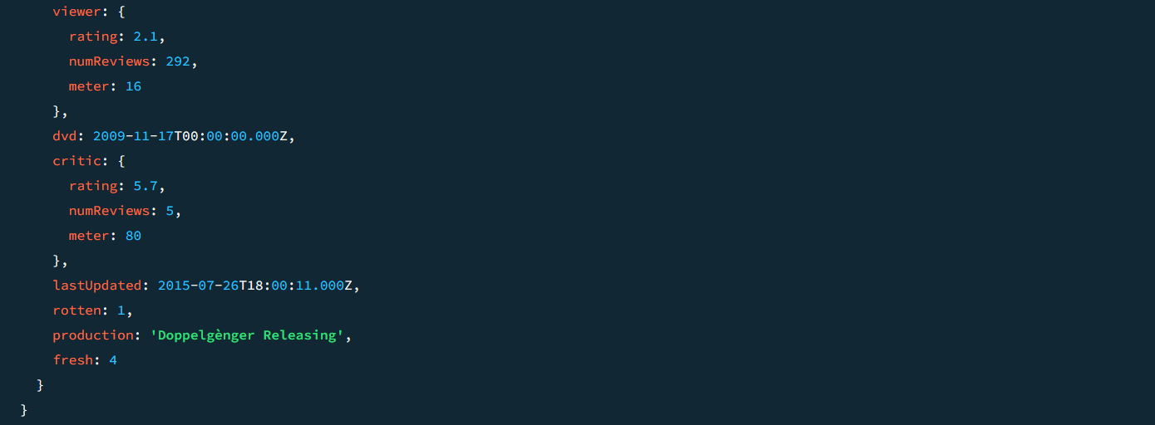

2️⃣ Find Potential Sequel Candidates
(High ratings, large audience, released over 5 years ago)

Edit
db.movies.find({
"imdb.rating": { $gt: 8 },
"imdb.votes": { $gt: 100000 },
"year": { $lt: 2018 }
})
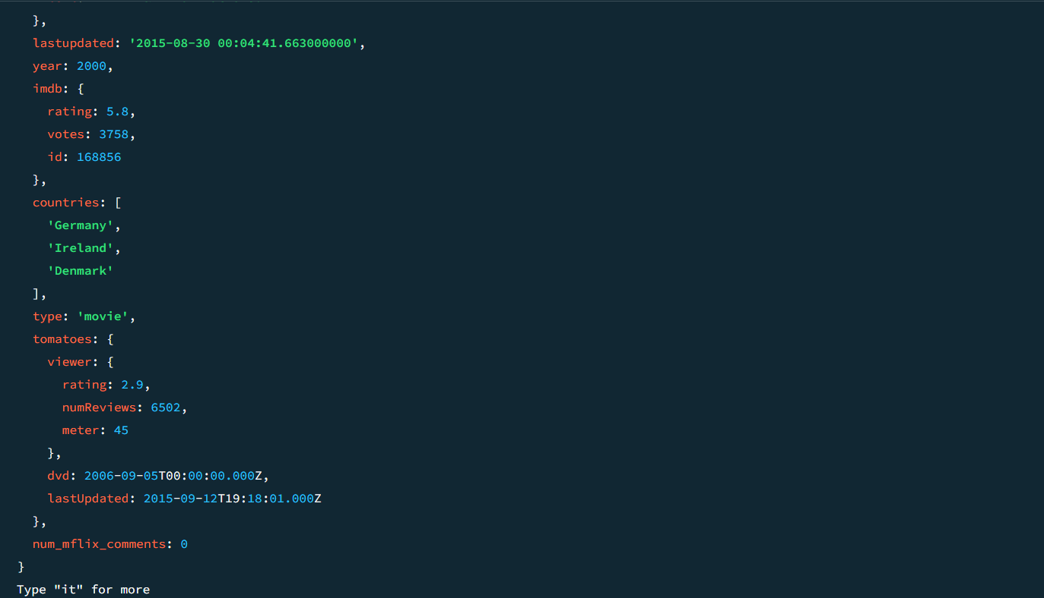

3️⃣ Find Underutilized Directors
(Directors with few movies but high average ratings)

Edit
db.movies.find({
"directors": { $size: 1 },
"imdb.rating": { $gt: 8 }
})

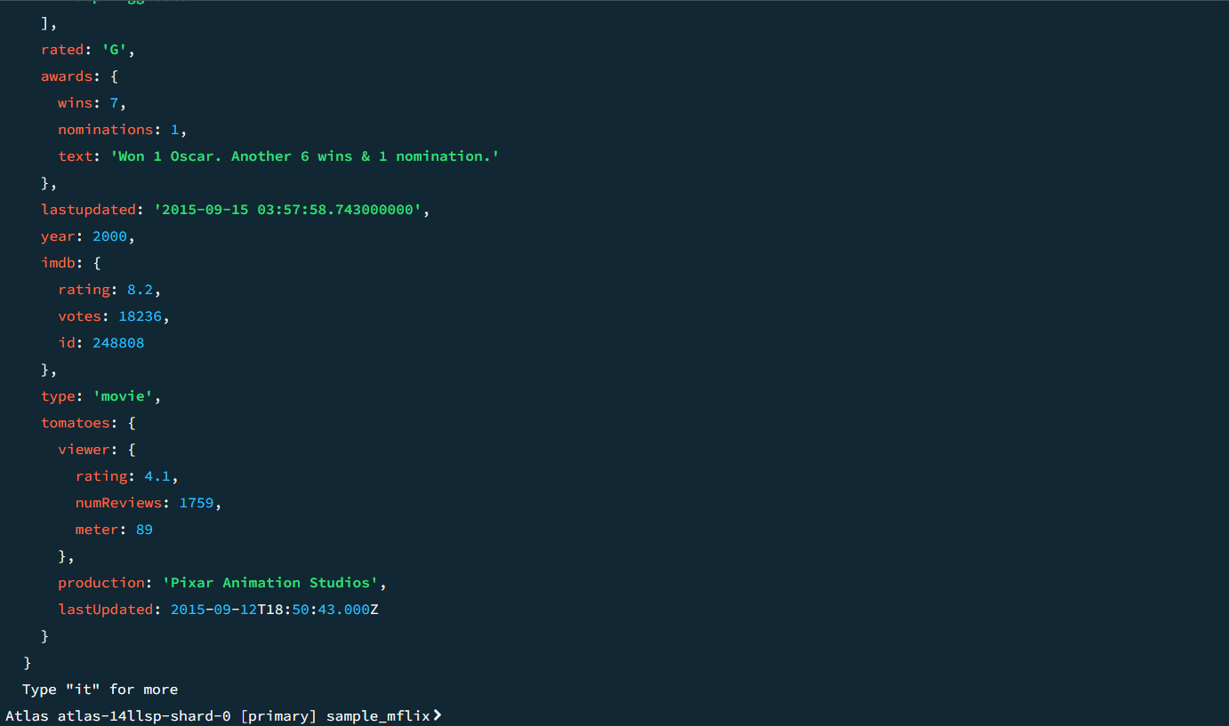

4️⃣ Find Movies That Resonate with Global Audiences
(Movies produced in multiple countries with high ratings)

Edit
db.movies.find({
$expr: { $gt: [{ $size: "$countries" }, 2] },
"imdb.rating": { $gt: 7 }
})
